# 

# 

# An incubated co-working space for technology innovation

## Internal Document Template

**Monthly Report**

**E-Ntsika_Yezwe**

**Table of Contents**

1

An incubated co-working space for technology innovation 1

Internal Document Template 1

Document Change Log ii

Definition of Terms iii

Description of Acronyms iv

1 Executive Summary 1

2 The Team and Responsibilities 2

3 The Timeline 3

4 Product Definition 5

5 Design Problem and Objectives 10

6 Product Specification 12

7 Product Development 19

8 Best Practice in C# App Development 24

9 Challenges faced by the team 26

10 Challenges faced in Project Management 28

11 Conclusion: 30

12 References 31

# 

# Document Change Log

This is a working document, which will be maintained with time. Team members, please ensure that any changes are recorded in the change log below – this is to ensure that each team member is always clear about which changes have been made and when.

|  |  |  |  |
| --- | --- | --- | --- |
| **Version** | **Date** | **Author** | **Description** |
| 0.01 | 21 March 2015 | Malusi Gcakasi | Created initial template document. |
| 0.02 | 23 May 2015 | Masixole Bodla | Edited information |

# Definition of Terms

|  |  |
| --- | --- |
| **Term** | **Definition** |
| Central Team | Team physically located at The Cortex Hub, East London |
| Remote Team | Team physically located outside of The Cortex Hub, East London |

# Description of Acronyms

|  |  |
| --- | --- |
| **Acronym** | **Description** |
| CH | The Cortex Hub |
| CT | Central Team |
| RT | Remote Team |
| EPM | Entrepreneur Profile Manager |

# Executive Summary

This document is aimed at reporting on the events that took place in the month of May 2015. It reports on the steps which were taken by the group E-Ntsika_Yezwe in the monthly project that was assigned to us by the remote team. We were tasked with providing daily podcasts on the .NET and its framework and we were also asked to develop a working C# based desktop application. This document will further specify what went into completing this task over the month of May 2015, it will identify the team members and their roles and also look at the set timeline for which events should be done by when and also evaluate whether we as a team have been meeting those set deadlines.

We as a group decided that we are to design a desktop application for CH entrepreneurs and the remote team which would allow the remote team to track the individual progress of each entrepreneur at the hub. This application would allow each entrepreneur to build their own working profile which would include a short biography of their lives, tasks that they have been tasked with and whether they completed those tasks, what they learned from the completion of those tasks, books that they have read and what they have managed to gain from reading those books, short book reviews on the books that they have read and they would be able to use this app as a day to day diary of the events that will take place at the hub and their role in those events.

This desktop application is to be designed using visual studio and its back-end functionality will be coded using C# programming language and all this is to be done within the .NET framework. Both .NET and C# will be defined in detailed further in the document and the team will also be defined and the team detailed plan on what the team objective is, how the tem will go about setting out strategies to meet those set objectives. It will also be discussed as to who is responsible for which section of the work and when they should finish their work and all this should be in correspondence with the designed group timeline.

# The Team and Responsibilities

**Masixole Bodla:**

He is the group leader and responsible for a number of tasks including but not limited to playing liaison between the team E-Ntsika_Yezwe and the RT. As group leader he is also expected to provide direction for the team and oversee the work of the other team members to ensure that everyone is doing what they need to do in order to meet and manage the expectations of the remote team. However as a team leader he is expected to:

* Conduct research on how good programmes are designed within the set boundaries.
* Research extensively with Sinaye Kondile the development of desktop applications using C#.
* He is also to spearhead the writing and construction of the 40 page report on what the group has done and how they went about developing their desktop application.
* He should also facilitate the execution of work by all the individuals in the team.

**Sinaye Kondile:**

He is the IT orientated guy of the group and he has a bit of coding background which could be extremely beneficial to the team. He is also tasked with various duties within the team and his role includes:

* Research how desktop applications are developed using C# and he is responsible for designing the application’s look and feel.
* He is also to coordinate the working processes on how the team will go about developing the desktop application and is to assign individuals in the team with specific roles in the development of the application.
* Manage and facilitate the process of building the actual application.

**Zukisani Nyayeni:**

He is group secretary and with that role is responsible for all out going documents of the group and is the person who is responsible for ensuring that all submissions are made on time. As part of the team his role include:

* Doing research on .Net framework.
* Facilitate the daily podcasts.
* Look at the relevant topics to be discussed in the daily podcasts.
* Spearhead the .Net research and application of the framework to the relevant process.

# The Timeline

The product timeline is a five week detailed process of what is going to be done each week with regards to the project. All the activities that should be performed and who is responsible for each of those mini tasks and when all compiled the end goal is to have a fully functional product. The time line is as follows:

* Week One: 30 April – 02 May

Zukisani constructed a 5 paged presentation on the .Net framework, what it is and what it does.

Sinaye also prepared 5 slides on what desktop application are.

Masixole also should prepare 5 slide presentation on what reports are.

All the above mentioned topics were also podcast topics for the respective week.

* Week Two: 04 May – 09 May

Zukisani prepared two presentations of 5 slides each one focussed on how the .Net framework looks and the other looked at the things that can be done using that framework.

Sinaye also prepared a 5 slide presentation on the stages that should be taken when designing a desktop application.

Masixole broke down report writing into particular sections and explained what is to be in each of those sections of a report.

* Week Three: 11 May – 16 May

Sinaye is supposed to create the interface for the Desktop Application, Zukisani will be the one who is to look at ideas for potential apps that the team can build by analysing problems that are faced by the CH and Masixole is come up with creative ways in which the interface and the app can be linked and put together in order to come with an application that is fully functional and that will be of help to the CH entrepreneurs.

* Week Four: 18 May – 23 May

In this week the team will structure the work in order to start creating the application.

We will establish a plan and do all that needs to be done according to the set structure in order for the application to be developed,

We will also assign specific roles to specific people with regards to the building of the application and we will also start putting together the report and the coding of the application.

* Week Five: 24 May – 30 May

Work on application functionality and start testing the application to see if it does all that is required from it. The application demo will be submitted to the RT on May 30th 2015.

# Product Definition

C# Programming language.

* C# is a general object-oriented programming language for networking and web development and is specified as a common language infrastructure language.
* The language was developed in 1999 by a Dutch engineer Anders Hejlsberg as a component of Microsoft .Net framework and it was initially called C-Like Object Oriented Language.
* Trademark issues meant that the name had to be in changed in January of 2000 and it improved and updated many C and C++ features.
* Using the C# language one can create various things these may include:
* Websites that requires server side logic such as business logic, data submission or dynamic content generation.
* Create a web service that can be consumed by other applications.
* Develop desktop applications for varying purposes including business uses.
* Develop games using DirectX SDK.
* Interact with just about any flavour of database to input, store, manipulate and retrieve data.

.Net

* .NET is a programming framework created by Microsoft that developers can use to create applications easily.

Vision of .net

* .integrate business applications and processes. Laptop, desktop, mobile phones, small devices all these device have support of .NET. That means the user can use any device at any place and at any time true internet and connect to the server.

.Microsoft .net frame work

* It is a software framework developed by Microsoft that runs primarily on Microsoft windows.
* It is also a platform that provides tools and technologies that you need to build networked applications as well as distributed web services and web applications.

What can we do using .net

- Mobile applications

- Desktop applications

- Web applications

Types of programmers

- System programmer is the one who programmes directly for a given hardware e.g. Device drivers.

- Application programmer is the one who programmes applications used by people for their requirements e.g. calculator, calendar, and accounting packages.

Definitions

- Platform is an environment for developing and executing applications.

- Development platform is where programmers would sit and write codes.

- Frame work is ready to use collection of classes and interfaces used for developing a particular type of application.

Designing Desktop Application.

* Desktop Applications:

It is an application that runs stand alone in a desktop or laptop computer.

Types of desktop applications

* There are countless desktop applications out there, and they fall into many different categories. Some are more full-featured (like MICROSOFT WORD), while others may only do one or two things (like GADGETS). Below are just a few types of applications you might use:
* Word processors: A word processor allows you to write a letter, design a flyer, and create many other types of documents. The most well-known word processor is MICROSOFT WORD.
* Personal finance: Personal FINANCE software, such as Quicken, allows you to keep track of your income and expenses and create a budget, among other tasks. Most personal FINANCE programs can automatically download information from your bank so you don't have to manually type in all of your transactions.
* Web browsers: A web browser is the tool you use to access the Internet. Most computers come with a web browser pre-installed, but you can also download a different one if you prefer. Examples of browsers include Internet Explorer, Firefox, GOOGLE CHROME, and Safari.
* Watching a movie in Windows Media Player
* Games: There are many different games you can play on your computer. They range from CARD GAMES such as Solitaire to action games like Halo 2. Many action games require a lot of computing power, so they may not work unless you have a newer computer.
* Media players: If you want to listen to MP3s or watch movies you've downloaded, you'll need to use a media player. Windows Media Player and iTunes are popular media players.
* Gadgets: Sometimes called widgets, these are simple applications you can place on your desktop (or on the Dashboard if you're using a Mac). There are many different types of GADGETS, and they include calendars, calculators, maps, and news headlines.
* User Interface: typically involves those objects that a user sees and interacts with directly on their screen. For example, such objects include the document space, menus, dialog boxes, icons, images, and animations.

However the user interface of an application is only one aspect of the overall user experience.

* User experience that are not visible to the user, but are integral to an application and critical to its usability, include start up time, latency, error handling, and automated tasks that are completed without direct user interaction.

In general, a user interface requires action by a user to accomplish a task, while a great user experience can be achieved with no user interface at all.

*Three phases of developing an app:*

*Designing*

Functional requirements – Determine the initial requirements and goals for the application.

User analysis – Identify the user scenarios and understand the needs and expectations of users for each scenario.

Conceptual design – Model the underlying business that the application must support.

Logical design – Design the process and information flow of the application.

Physical design – Decide how the logical design will be implemented on specific physical platforms.

*Implementing*

Prototype – Develop paper or interactive screen mock-ups that focus on the interface and don't include distracting visual design elements.

Construct – Build the application and prepare for design change requests*.*

*Testing*

Usability testing – Test the application with various users and scenarios.

Accessibility testing – Test the application with accessible technologies and automated test tools.

# Design Problem and Objectives

At the CH entrepreneurs are tasked with various different tasks and they face various diverse challenges within these tasks. The entrepreneurs however do not keep diary of these tasks and they do not have a formal log book in which they can write down all their successes and challenges in. This type of log book or diary is a necessity for all entrepreneurs of the hub because this would ensure that all their work is documented and kept safe. This would also help them when they have to recall what they did while at the hub. Why is it important to keep a diary of all the events, tasks and record of progress of each entrepreneur?

* Information should always be organised and kept safe.
* It’s important to keep record of progress because that could form part of the resume of the entrepreneur.
* This will also allow the remote team to see how the entrepreneurs are growing at the hub and what skills and knowledge they have acquired.
* This would make it easier for the remote team to rate individuals based on the work that they have put in.
* Creating an image and profile is an essential part of being an entrepreneur and to be successful as an entrepreneur you need to grow that brand that is you.

Due to the above mentioned factors and statements we as E-Ntsika_Yezwe have decided to create an application called My_Profile. My_Profile is a desktop application that allows a person to build their own work profile according to tasks that they have done and completed. This profile is made out of the personal lessons that an individual would derive from each of those tasks; this can be seen as a platform in which one can do personal reflection and evaluation with regards to the expectations that are placed on them by the remote team. My_Profile does not only look at the mere tasks that a person has done but it goes as far as having sections for book reviews, personal notes and it allows you to add all your other interests that may not be work related but one feels that are important to them in this quest of becoming an entrepreneur.

**Objectives of the App:**

* Have a system that is standard and will help individuals document their progress.
* Have and internal platform that allows the Cortex Hub management team to see the progress of entrepreneurs anytime and anywhere, from the entrepreneur.
* Help entrepreneurs have a professional application that is an easy to use platform to organise information about themselves.
* Improve entrepreneurs report and academic writing skills.
* Help built a case as to who people are and what they have accomplished.

**The benefits of EPM are plentiful and they include:**

* Helps individuals keep track of their work production and always have record of what they did, when they did it and what they gained from doing it.
* It is an easy way for Management to assess the entrepreneur’s individual opinions of what they believe they are gaining from being at the hub.
* It can serve as an events diary and reports book for entrepreneurs.
* The information is secured and shared only amongst the entrepreneurs and remote team.
* It will management compare what they want people to be learning with what people say that they are learning.

# Product Specification

Structure of Events

For The Desktop Application

Add Personal Comments and Notes

Leadership

Teams

Projects

Tasks

Books

Biography

User ID

User Password

U

Step One

The initial first step of creating the application is to create a database which will have a list of all the CH entrepreneurs. On this data base each entrepreneur will have a name, surname and other relevant work details.

Each user would have a User ID created for them which they will be required to use when accessing the system so that the application can relate that particular user to the details that he or she is identified with on the database.

The entire User’s will be assigned with a password that they will use to have access to their profile page on the application. Certain restrictions and rules will apply to the use of the application, these restrictions will be placed on the back-end of the application and these will help protect the system from potential abuse or misuse.

In the application each user will only be allowed to edit their own personal profiles, this means that they will be the ones whom keep their profiles up to date. As much as a user can only edit their own information they will have access to other people’s profiles. They will be able to read and look at other people’s profiles but not be able to edit any of their information.

Step Two

Application Breakdown

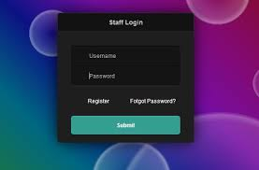

1. The first screen of the application will be the login screen that will ask a person for their Username and Password. These will be the ones that have been assigned and given to all the relevant stakeholders in advance by the administrative team. Once logged in the user will be redirected to a page that will have pictures and names of all the other entrepreneurs.

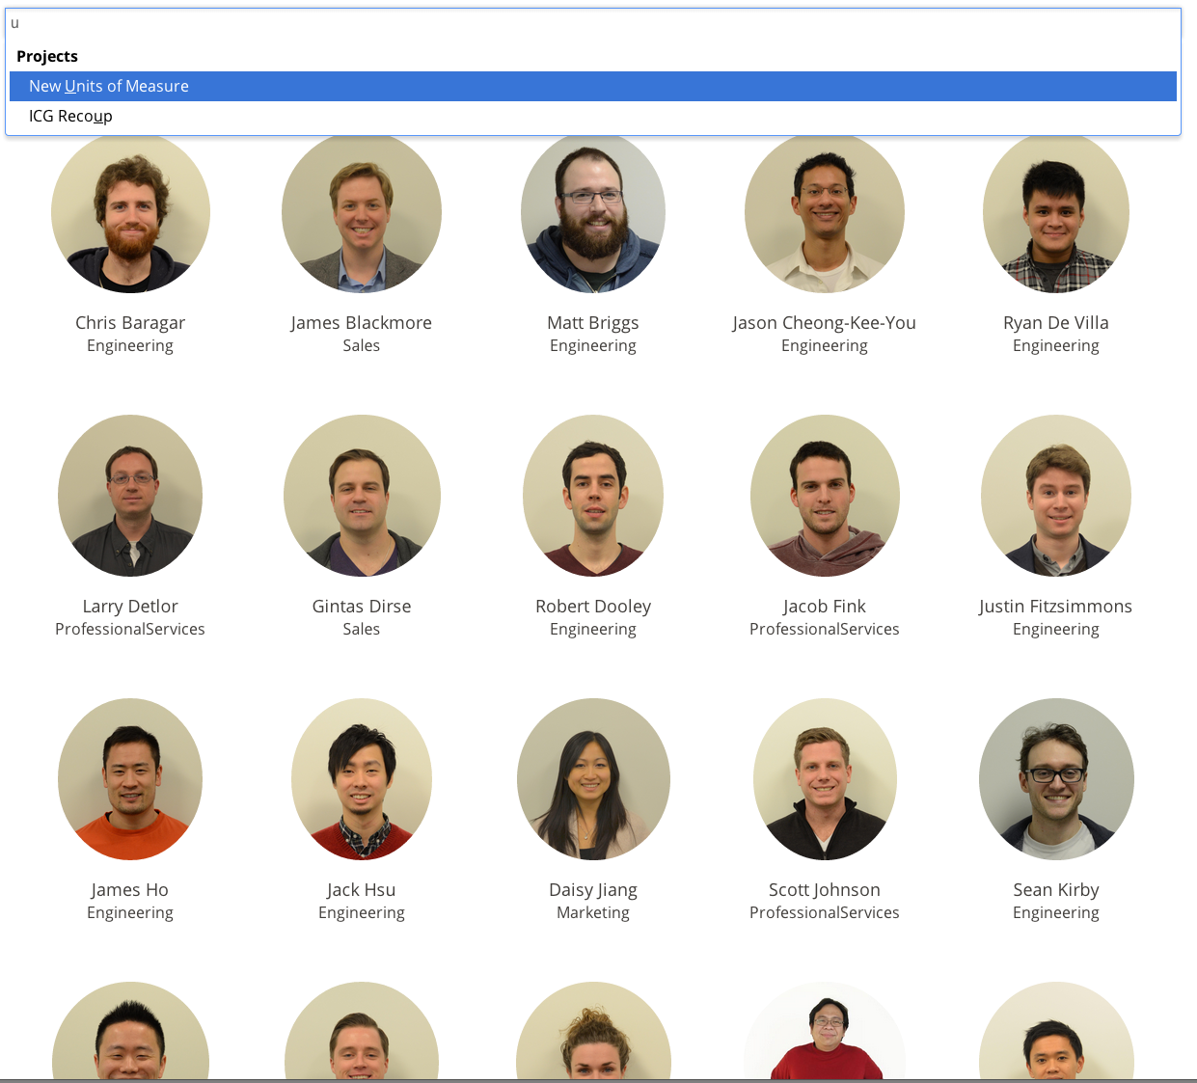

This is an example of the second page.

1. On the second page is where all the entrepreneurs profiles will be and all the entrepreneurs will have their pictures and names on the page which simply show who each entrepreneur is. When you click on a picture you will be redirected to another page that will allow you to see the actual profile of an individual. This would include their biography, Tasks completed, Books they have read and so forth. The user cannot manipulate this information but should they click on their profile they will be able to edit, update, add or remove information from their own personal profiles.

:

Under Biography the entrepreneur will have they journey leading up to being an entrepreneur of the hub. This will include when they were born, where they were born, parents and family information should they wish to share this information with other people, they will speak about where they received schooling and what leadership roles they occupied throughout their schooling days, and they can also speak about what inspires them as people and why they decided to become entrepreneurs. In this biography the user basically tells a story about life before the CH and they specify all the details of their life they wish to let people know.

:

Under this tab a user will be able to add a task, remove a task or modify a task that they have completed as individuals or a group. They will say what they task was and what they were required to do in the task. The most important aspect of this tab is that it will also allow the user to individualize the task and make it specific to them, they can achieve this through stating all the knowledge and skills that they have gained from completing that specific tasks. They will also say whether or not they believe they grew or not from completing that task, this will also help the RT check if people derive the skills that they had intended them to gain when they issued out the instructions for the task. This will also assist the entrepreneur should they be asked to state what they have done at the time they have been a member of the hub, they can always refer back to the app to the get all the required and necessary information.

:

All CH entrepreneurs are now required to read specific books to gain or accumulate additional knowledge. This is also a task in its own right however the reason why has its own specific section in the app is due to the fact that the entrepreneur might want to have reviews written down on the books that they have read and that is where this tab will come in handy. In this section the entrepreneur will add a book that they read and they will make a title, author and review entry in the tab. They will also be able to take out their favourite quotes from the book and make they own personal comments as to what the learned from reading the book. This tab will also allow the entrepreneur to rate the book and maybe add why it is a good read and why they would recommend the book to other people. This will also help the remote team track whether or not people are putting in the required effort into actually reading and understanding the books that they read.

:

One might make the assumption that this is an unnecessary tab especially because there already is a tab for tasks. However this would be wrong due to the fact that there is a slight if not monumental difference between tasks and projects. The major differentiator between the two is that tasks are sometimes intangible while projects require that there be a tangible viable product or end result. The other difference is that the tasks will be assigned to entrepreneurs either by the RT or another higher authority like chairman. As you maybe are aware that there are special projects beside the orthodox ones that are assigned to us by the RT, these side projects may include planning of the women event by one team and being part of the drones’ team. These two projects are examples of things that people are a part of that are not part of the CH curriculum they should therefore have the platform to write about these projects and that is what this tab is for. This is where they can write about what role they are playing within these side teams and projects and what skills their gaining from being part of these teams. This will also indicate to the remote team which people out their hands up to acquire more knowledge and skills without having to be tasked or assigned things.

:

At the CH half the time entrepreneurs are assigned groups that they have to work in and in these groups they get to work with different people. From those people that they are grouped with, they acquire certain things and learn specific values and ethics. This is the tab where they get to express appreciation and make comments on the individuals that they had worked with. They can write about the challenges that they faced with working with certain people in certain groups and how they overcame those trials and challenges. For the RT this will be great help especially when they need information to correspond with the evaluations each entrepreneur has to make with regards to other entrepreneurs. This is where they can find the reasoning behind why an entrepreneur might have rated another entrepreneur in a certain manner.

:

All CH entrepreneurs are presented with the chance to become leaders, be it in the executive team or the leader of a group. This tab will allow them to add the roles they had when they were part of these leadership structures and they can also write about what they experienced and learned from being part of leadership. They can also add comments challenges faced when they were leading and how they worked and managed their time. This could be valuable information and they get to share this with other entrepreneurs and the RT which means that people who are looking to be in leadership would know exactly what is it takes to lead. This will also allow people to state what they did as leaders and what they would define leadership as. This will provide insight on whether or not some structures of leadership that exists within the CH truly are necessary and actually give people the experience that they will need one day to lead their own organisations.



This tab is there for people to write just about anything that is on their mind that they wish to share with other people. It could be personal to them or be a movie that they watched and recommend that other people watch and also state why they think it’s important that others do watch this. They can also write about new tech trends or business opportunities they think that other entrepreneurs should look at. They can also write here about the problems that they are facing at the hub and ask for help from either the RT or other entrepreneurs. This will also be a platform for sharing ideas and looking for people with the right skills and abilities to help.

# Product Development

The product development is an essential stage of the team’s assigned tasks and it is a stage that required significant planning and implementing. On top of that it is also a stage that has multiple phases that should be implemented. These phases include:

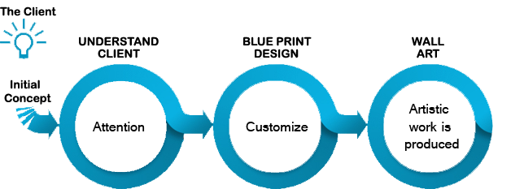

Phase One: Conceptualizing

In this stage the team got to come up with various concepts on the look and feel of the application. In product specification we have laid out what the product should be able to do and showed an idea of how we would like it to look like. However this functionality requires user interaction and part of coming up with these concepts is to find the proper application and user interaction design. This includes drawing up the user interface (It is defined and explained earlier in the document) and try derive a satisfactory user experience and in our concept these are two most dominant factors to consider as any concept we come up with will truly be defined by these two functionality factors.

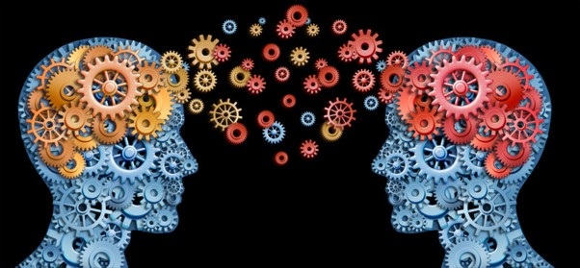

Phase Two: Design

The team used visual studio and the C# programming language to design the actual product and this entailed that we design every page of the application individually. This meant that we had to ensure that we know where everything is going to sit and what purpose it will serve. In doing all this we had to keep in mind that the design of the product should allow the functionality that we want from the product and that all the things we have mentioned in the product’s specifications were actually accomplished by the product. This also meant that we had to make a decision on the concepts that we discussed and choose which one is more suitable for what we have designed and if it meets all the user abilities that we wanted to enable.

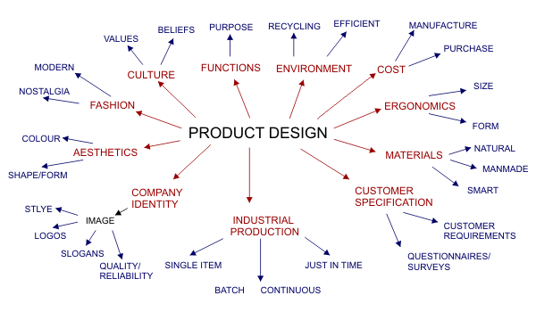

Phase Three: Database Creation

A database can be defined as a structured set of data held in a computer, especially one that is accessible in various ways. “In one view, databases can be classified according to types of content: bibliographic, full-text, numeric, and images. In computing, databases are sometimes classified according to their organizational approach” Margaret Rouse. Our database required both classification and computing abilities in order to be able to perform all the required duties. The team developed two different databases for the application and this was done in order to have specific information be called in a certain way and to distribute information and data so that one database is not overloaded with too many variable and data. The inputs of the first database included username and user password which is linked to the second database that include name, surname, employee id and contact details. The first database is created in order to be linked to the first page of application which is going to ask for a username and user password and these two factors will be assigned to users by the administrator of the application. All this information will be linked to the second database with the details of the users, so that the application knows whom each name and password belongs to when they login so as to place certain restrictions on what users are able to do on the application.

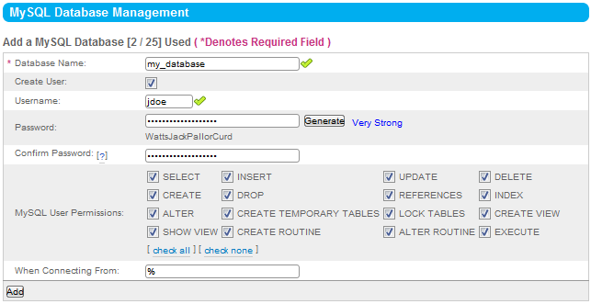

Phase Four: Programming

This is the phase of writing the programme or creating the software of your application.

We have used C# programming language to build our application. We started by creating the interface of our application and then we went on creating the database.one of the challenges we faced is the problem of lack of coding skills among the team which requires an intense self-learning to come up to the stage where you can build an application. We also encountered a problem after we finished creating the data base now the problem to link the data base with the logging screen. That was the most challenge we faced because the everything was done according to the plan now our programme could not find the database which was created. 

Final Phase: Testing

The testing phase is perhaps the most essential part of application development, it is important because it allows you to test various aspects of your application. These aspects include various different test like testing to see if the product actually is completed to the set specification or standards, test to see whether or not the product actually is the ability to perform the task for which it was initially created and the final tests is to actually use the product to see if it will not have certain difficulties when exposed to actual work and challenges.

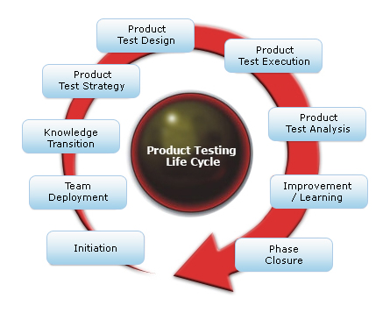

# Best Practice in C# App Development

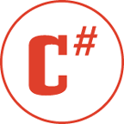

Let’s start discussing the Best Coding Practices of C# application development. Here are some of them:

Use proper Naming Conventions

* Always use Camel or Pascal naming format.
* Avoid all uppercase or lowercase names.
* Never use a name which begins with numeric character.
* Always prefer meaningful names for your class, property, method, etc.
* Never build different names varied by capitalization.
* Don’t use the same name used in .NET Framework.
* Avoid adding prefixes or suffixes for your identifiers.
* Always use “I” as prefix for Interfaces.
* Always add “Exception” as suffix for your custom exception class.
* Never prefix or suffix the class name to its property name.
* Prefix “Is”, “Has” or “Can” for boolean properties.
* Don’t add prefix for your controls.

Decide between Value Types and Reference Types

1. Always Use Properties instead of public variables.
2. Use Nullable data types whenever required.
3. Prefer Runtime Constants over Compile time Constants.
4. Prefer “is” and “as” operators while casting.
5. Prefer string.Format() or StringBuilder for string concatenation.
6. Use Conditional attributes when you need them.
7. Use ‘0’ (zero) as default value enum value types.
8. Choose between Equals() and Equal (==) operator.
9. Always prefer the foreach(…) loop.
10. Initialize member variables at the time of assignment.
11. Initialize static member variables with static constructors.
12. Use constructor chaining whenever possible.
13. Minimize boxing & unboxing of objects.
14. Properly utilize try/catch/finally blocks.
15. Catch only that Exception which you can handle.
16. Use IDisposable interface.
17. Utilize LazyInitializer in most of the cases.
18. Split your logic in several small and simple methods.
19. Try to use Patterns & Practices like MVP/MVC/MVVM.
20. Always prefer DataBinding to populate values in the UI.

# Challenges faced by the team

Lack of Diverse Skills and Interests

If a team consists of members with similar skills and interests, the purpose of the team may not be achieved. Consider the scope of the project before selecting team members to determine which skills and interest’s best serve the team.

Poor Communication

When individuals work as part of a team, communication during all phases of the project is a key component. If a team member treats his role as an independent one, communication suffers. If the team leader doesn't communicate with the team members, the project flow suffers.

Lack of Leadership

Teams need leaders to offer a sense of purpose and direction. Lack of effective leadership challenges effective team development. Without a strong leader to guide the team and hold members accountable, the team may lose morale and momentum. Commit yourself to monitoring the team's performance and offering support as needed.



Role Confusion

Even though a team works together to achieve a goal, each person needs to know his specific role within the team. Otherwise, role confusion results. When team members lack an understanding of their specific roles or choose not to follow through with their roles, the team cannot develop as a cohesive and well-functioning unit.

Conflict

Conflict within a team is inevitable. How team members deal with conflict is critical to team development. With the skills to effectively resolve conflict, your team can work together to stay on track without your constant intervention.



# Challenges faced in Project Management

**Undefined Goals:**

When goals are not clearly identified, it is impossible for the team to meet them. And, since upper management cannot agree to or support undefined goals, the project in question has little chance of succeeding.

**Scope Changes:**

Also known as "scope creep," this phenomenon occurs when project management allows the project's scope to extend beyond its original objectives.

**Inadequate Skills for the Project:**

A project sometimes requires skills that the project's contributors don't possess.

**Lack of Accountability:**

A project manager's leadership qualities really shine when each member of the team takes responsibility for his or her role in achieving project success.

**Improper Risk Management:**

Learning to deal with and plan for risk is an essential piece of project management, this was a common problem in our team.

**Ambiguous Contingency Plans:**

It's important for project managers to know exactly what direction to take in pre-defined "what-if" scenarios. Which we lacked in our team.

**Poor Communication:**

Project managers provide direction at every step of the project, so each team leader knows what's expected.

**Impossible Deadlines:**

A strong leader - and successful project manager - knows that repeatedly asking a team for the impossible will result in declining morale and productivity.

**Resource Deprivation:**

In order for a project to be run efficiently and effectively, management must provide sufficient resources - human, time and money.

**Lack of Stakeholder Engagement:**

A disinterested team member, client, CEO or vendor can destroy a project quickly.

**Split attention:**

Running too many facets of the project at the same time can lead to confusion, wastage and missing of deadlines.

# Conclusion:

Looking at the challenges and outcomes we faced while we were building this application as E-NTSIKA_YEZWE one of the things we noted is the importance of skills. Without the skills in the technology world there is nothing possible. Another thing we noted is the importance of proper planning before doing anything else it’s important to draw up a proper planning for everything you going to build. We have also learnt the importance of accountability, when you are working as the team accountability is so important if the is no one accountable when you are working as a team the will be no progress. Time management is the key is the most factor that have to be taken into consideration at all time in as much as you have drafted the plan but it’s important that your plan be aligned with the time.

# References

<http://en.wikipedia.org/wiki/.NET_Framework>

<http://vb.net-informations.com/framework/what_is_net_framework.htm>

<https://www.youtube.com/results?search_query=.net+tutorial+for+beginners&spfreload=1>

<https://msdn.microsoft.com/en-us/library/ms973829.aspx>